Bo Tang
Global Health Summer Program - Taiwan

I started my 4-week global health trip in Taiwan on June 15, eager to learn about the medicine and healthcare in a country I had never gone to before and excited to see the differences and similarities in treatment and patient care between Taiwan and the US.
Our first top upon arrival was in XinGang, a small but lively town located in the rural mid-western part of Taiwan called Jiayi. With more than 65% of their population consisting of those over 65 years of age, there was certainly a plethora of health care disparities for us to learn from. The majority of the population comprised of farmers or retired farmers, as most of the younger able-bodied generation had moved out to better prospects in the major cities in the north. This resulted in a large vulnerable population in XinGang who had no stable family support at home to look after them. As a result, the citizens of XinGang all looked after each other and were a very tightly-knit community.
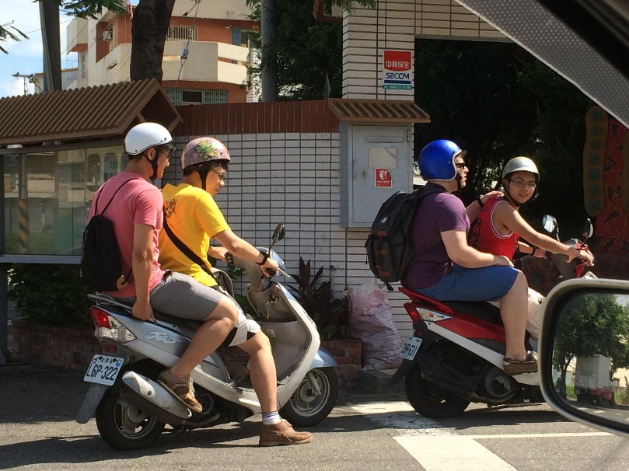
As we traveled with students from the National Taiwan University Medical School (NTUMS), we worked in cooperation with XinGang’s local non-profit Culture and Education Foundation to observe how the individuals in this community worked together to trouble shoot problems and better themselves. The principles behind the XinGang foundation was based primarily on upstream medicine, in which proactive methods are taken to decrease a risk factor before it escalates into a disease. One of the biggest problems in the XinGang population, or any population for that matter, is food. Many of the older population no longer work or have steady incomes, and do not eat regular healthy meals. Some have also become recluses, not leaving their homes to go to the market due to depression because their younger family members left. The XinGang Foundation addresses these concerns by working together with a local restaurant to make healthy meal boxes to be dropped off at the homes of these individuals. The deliveries are performed by volunteers from the community who give their time to help their elders and friends in need. We were given the opportunity to ride along on some of the deliveries and visit. The recipients of the meal boxes were all very happy and grateful to see us, and eagerly invited us to sit and talk with them since they don’t get many other visitors. It was a wonderful opportunity to interact with the population; as medical students, it was also a great opportunity to take their histories and give checkups. Many do not have regular doctor’s appointments, and were more than happy to ask us questions about their health and have us care for them.
Getting ready to deliver food!
Another amazing opportunity we had was visiting a mobile health clinic that was having a health workshop the day we were there. Because of the huge disparity in healthcare between the big cities in Taiwan and the smaller villages in the countryside, hospitals and specialty care are not always easily accessible. The mobile clinic was comprised of a few coach buses that were outfitted with diagnostic and screening equipment such as x-rays, ultrasounds, and mammograms that drove out into areas of the country that had little access to healthcare. This type of mobile clinic was especially beneficial for patients who had difficulty moving around and leaving their villages. To promote participation, karaoke contests, free haircuts, and massages were also offered by volunteers traveling with the clinic. Physicians of various specialties set up tables to answer the community members’ concerns, do blood tests, and perform general checkups. Dental and eye screenings were given as well, in addition to traditional medicine pharmacists who gave drug advice and promoted medical compliance. Public health advocates and local comedians kept the atmosphere lively and the entire event was very well-received. It was very heart-warming to see an entire community so involved and happy about healthcare.
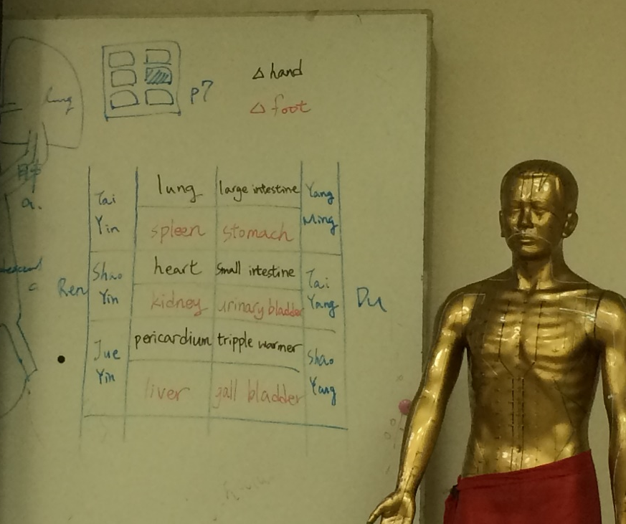
We spend the second half of our trip at Taiwan Veteran’s General Hospital (TVGH) learning about traditional Chinese medicine (TCM) at their traditional medicine clinic. It was interesting to note that the hospital had a separate location for the Chinese medicine clinic apart from the rest of the hospital, even though many of the patients visited both and prescribed to both forms of medicine. While the acupuncture sessions were fascinating, I was more interested in seeing the difference in healthcare in the TCM clinic in comparison to the rest of the hospital (which was more or less like the US). In the TCM clinic, patients stood in line for a brief consultation and checkup with an attending before entering a large treatment room for acupuncture. Unlike the private beds and rooms in US hospitals and clinics, the majority of the treatment room consisted of a large open space with chairs. Patients freely talked to one another about the reasons they were coming in to the clinic and weren’t at all shy about sharing their past medical history. In return, the other patients (oftentimes complete strangers!) would offer a comforting shoulder or advice or sympathy over the difficulties of life. The same sense of community and mutual support we observed in XinGang was also very prevalent in the clinic. Seeing how the difference in culture effects how healthcare is performed and received was really an eye-opener in just how varied medicine would be internationally.
To my regret, the program was only 4 weeks and soon I was on a plane back to the US. I brought back with me a greater understanding of what patient-centered medicine means and how upstream medicine would be applied in our field. I was able to take away much from this trip, about not only medicine but also about culture and history and its effects on healthcare, and encourage others to go abroad and have similarly wonder experiences.

