My Medical Spanish elective in Costa Rica was, hands down, the best experience I had in all four years of medical school. There is nothing like studying language in another country to get you out of your comfort zone, teach you about life in other parts of the world, and leave you with useful skills that you can bring back to your practice of medicine.

I went to Costa Rica knowing almost no Spanish - maybe a few nouns and verbs, and common phrases like “Como estas?” - but I returned with the ability to carry on a brief conversation and especially, to understand when someone is speaking to me in Spanish. True, a month away is not going to make you fluent. But it can give you the basis you need to learn more Spanish, if you put in the effort to practice as much as possible. By the way, I now have an even greater appreciation for people who live in a country foreign to them, speaking their second (or third) language daily. It’s definitely not easy.

Five of us from RWJMS went to Costa Rica together, all females. Three of us had been friends beforehand, but didn’t know the other two. By the end of our trip, we had all bonded over our butchered Spanish in class (laughing at our own mispronunciations and errors of translation), our long bus rides on the weekends, sharing hostel rooms (plus sharing a bathroom with 4 other girls), and adventures in cities we had never known existed.

We lived with host families in San Jose, the capital city. The family my friend Stefanie and I stayed with was so warm and welcoming. We bonded with them very quickly and grew fond of our “mama tica”. We also developed a new love for telenovellas…

During the week, we took the bus (50 cents!) or walked to school. Hours of class may sound intense, and we DID have to study (at least a little bit), but we had so much fun with each other and our instructors that the time passed quite quickly. We got lunch at local restaurants and learned to appreciate freshly squeezed fruit juice! In the evenings, we had dinner with our host families, spoke mostly in Spanish in order to practice, did homework… and watched Spanish TV.

On the weekends, we traveled! Costa Rica is an absolutely gorgeous country. Interesting fact: Costa Rica contains around 5% of the entire world's biodiversity. There is so much to see. From beach towns like Puerto Viejo on the Caribbean coast, to central valley towns like La Fortuna and Monteverde, we experienced rainforests, wildlife reserves, volcanoes, the sea and the ocean. It was relatively easy to get to these places: we took buses from San Jose both ways. Public transportation by bus is quite extensive in major cities, and there’s always the option of the easy-to-spot red taxi.

If you have some Spanish fluency already, an excellent option is to do a program similar to ours, through the same organization, that gives you Spanish classes part of the time and places you in a clinic or hospital the rest of the time. Practice by speaking is really the best way to learn.
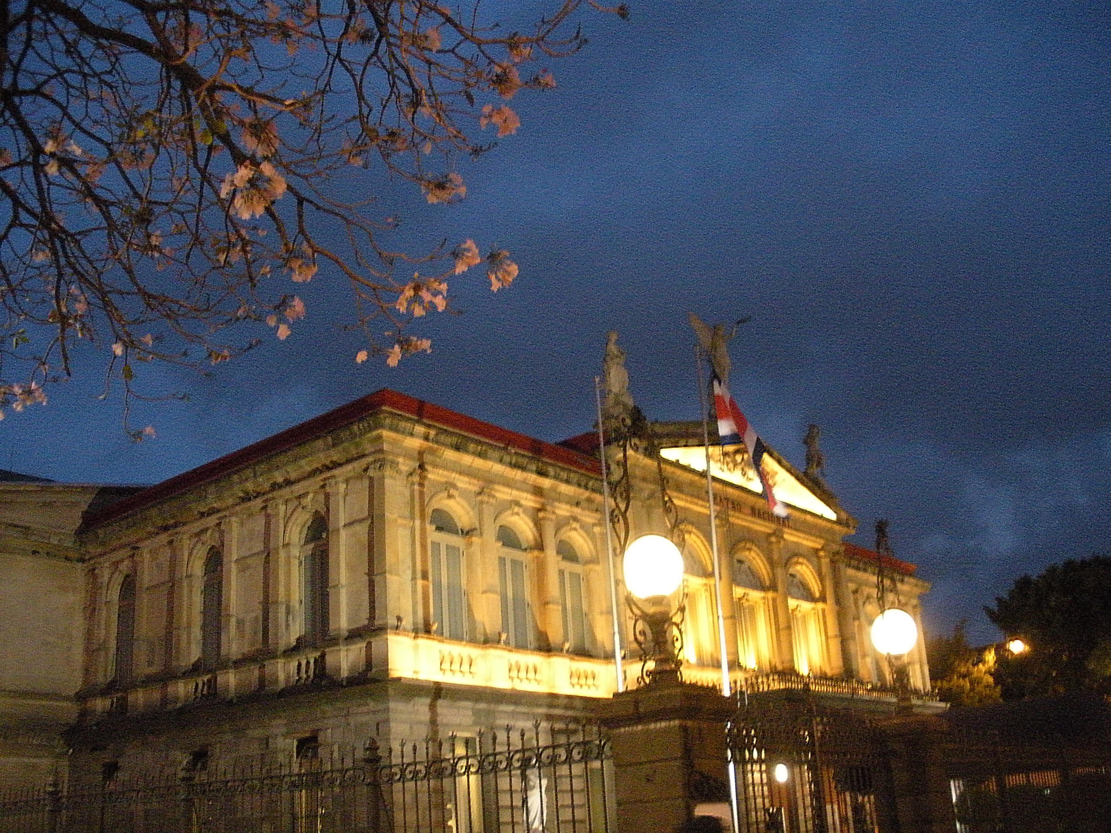

The gorgeous National Theater (Teatro Nacional) in San Jose.

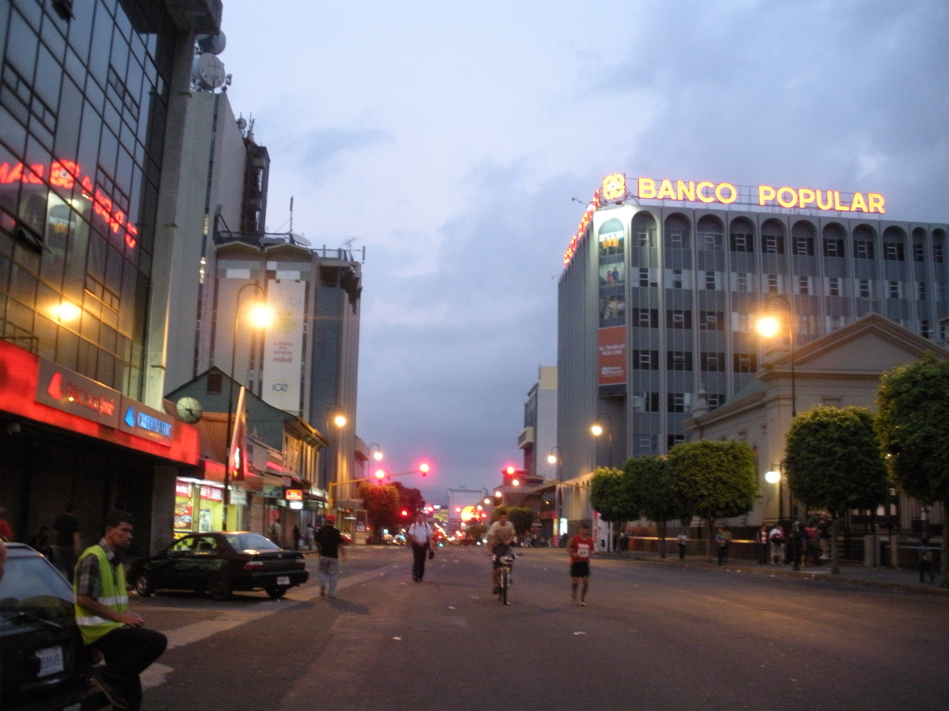

Bike race through city streets.

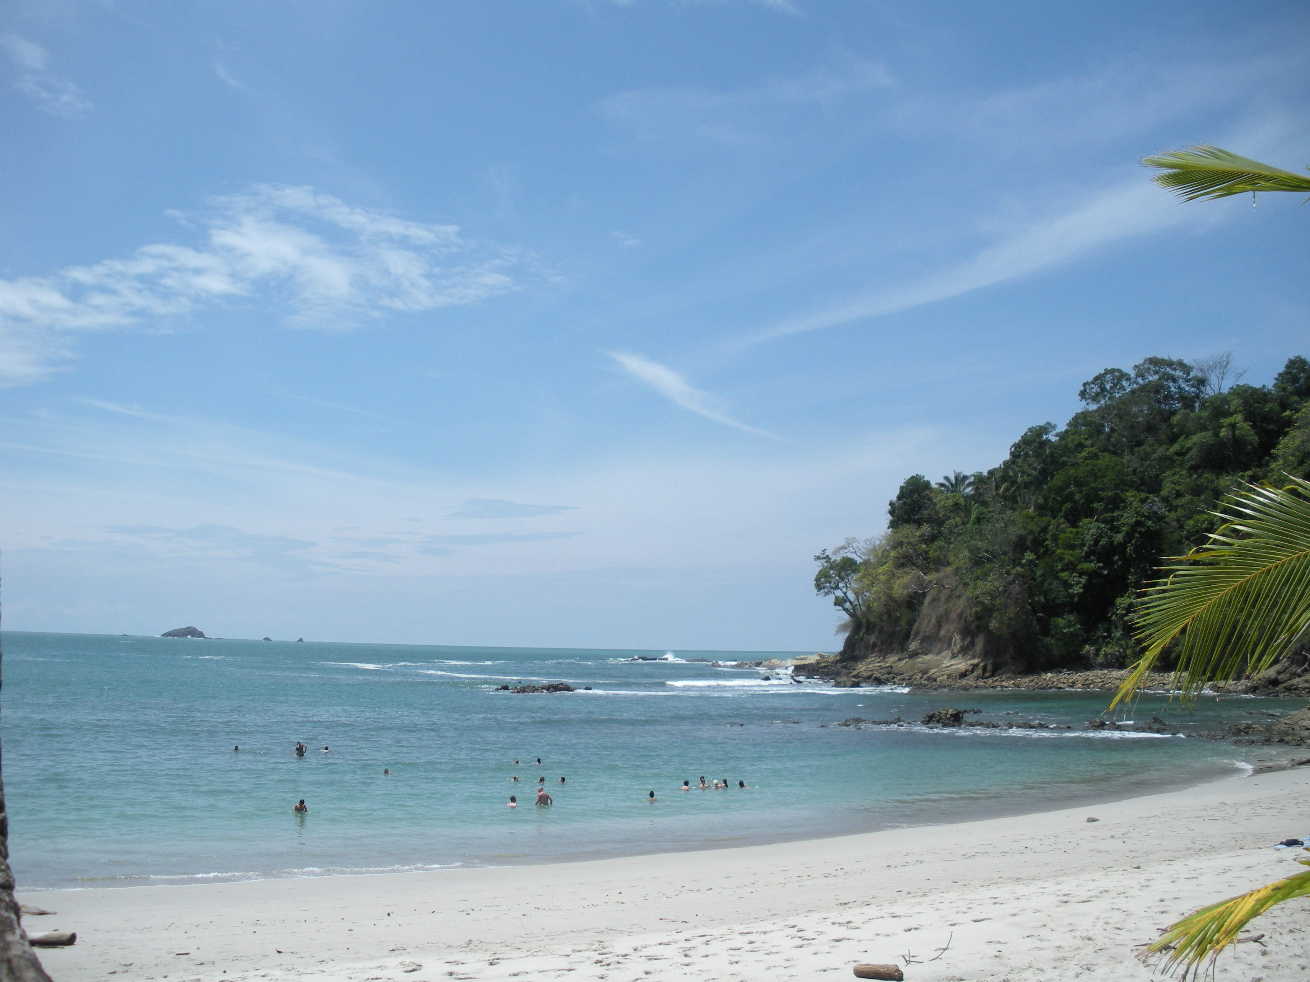

The beach at Manuel Antonio, on the coast of the Pacific Ocean.

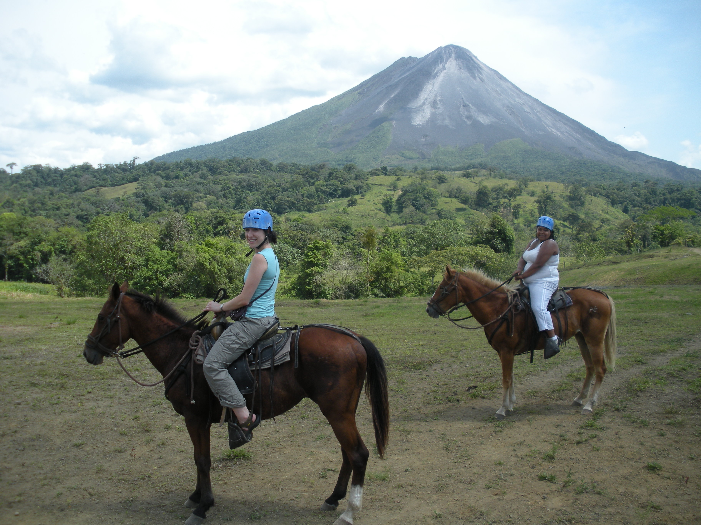

Yes. We are horseback riding… near an active volcano… in Costa Rica. A surreal and super-happiness-inducing experience.

