Mansi Shah Reflection
This past summer, I was a proud part of the Andean Global Studies (AGS) program. The program was based in Quito, Ecuador and had three objectives: an overall absorption of Ecuadorian culture, progression in the Spanish language, and exposure to the healthcare systems and medical facilities of Ecuador. I can comfortably say these three objectives were completed and they were an amazing four weeks.
The program consisted of staying with a host family in Quito and travelling to different landmarks and attractions throughout Ecuador on the weekends. I had a very sweet host mother and many host siblings, so it felt right at home. One problem, which I usually don’t face at home, was the food. My host family, and seem it seems most of Ecuador, weren’t used to seeing vegetarians and reacted to me as if I had eight heads. However, they were extremely accommodating and I was able to enjoy Ecuador’s exotic fruits and vegetables—and even got my family to indulge in more vegetarian food!
Regarding the travelling, I was able to cover almost all of Quito, either on foot or via public transportation. Public transportation, though it made me feel like a local, was dangerous because I was easily spotted as a foreigner and was a potential target for robbers. We quickly learned that it was best not to carry valuables on us and to reduce the use of English to a minimum.
My weekends were more relaxing and I had the opportunity to visit interesting places and capture some breathtaking views. The highlight of my weekend travels was being able to visit “Mitad del Mundo,” which translates to “Middle of the World.” It was a once in a lifetime experience because when else would I be able to have a foot in the two different hemispheres of the Earth at the same time?
While traveling and cultural competency were some of the objectives of the program, the focus was learning the Spanish language. Even though I have taken several years of Spanish throughout my school and college career, being able to apply those skills in a conversational, cultural South American setting is a completely different experience.
Our normal day consisted of attending Spanish lessons at our school during the mornings and having the afternoons free to visit some cultural landmarks in Quito. These lessons were additionally helpful because they covered a lot of medical terminology, which would be useful when we went into the hospitals. Another benefit of the classes was that they provided us with a chance to interact with other medical students from all around the world, including Germany, Japan, Switzerland, etc.
The most important part of this program was my exposure to Ecuador’s healthcare system and medical facilities. It was especially intriguing I was placed in a military hospital in its emergency room. My responsibilities varied from shadowing the physicians to working with the medical students to interact with patients to take simple medical histories. Moreover, I was able to learn and apply medical skills such as taking EKGs, inserting IVs, and much more. Towards the second half of my rotation, I was allowed to work in the triage facility, where I was able to check for vitals and take patient histories on my own.
Overall, I am very satisfied with my decision to spend a few weeks of summer in Ecuador. Of course when traveling, one will always have some ups and downs, but my experience was was a very positive one. From the medical aspect to the cultural aspect of it, I would recommend this program to any first year student with even the slightest interest of pursuing global health or international travel. The Andean Global Studies program is structured well to ensure all students get the perfect balance of cultural immersion and medical education.
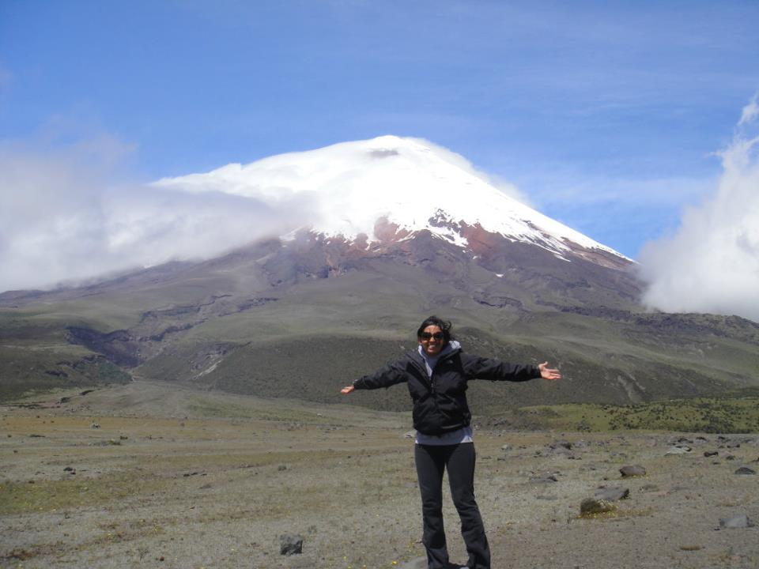Volcan de Cotopaxi 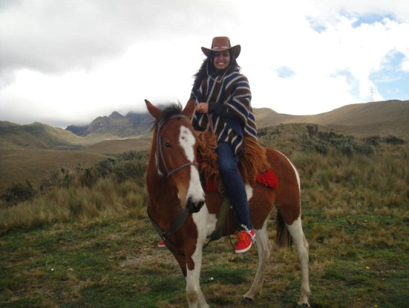 Teleferico, Quito
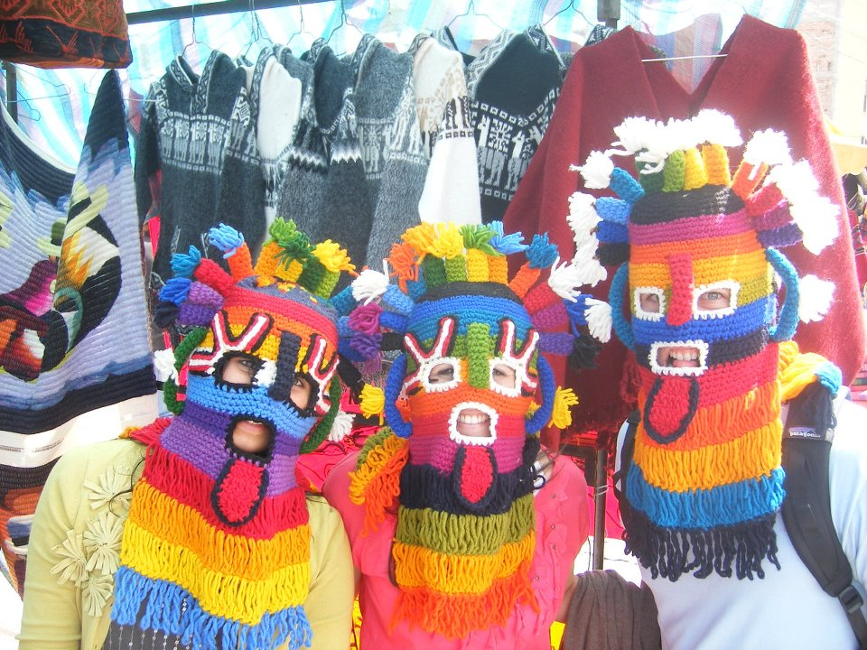 Otavalo
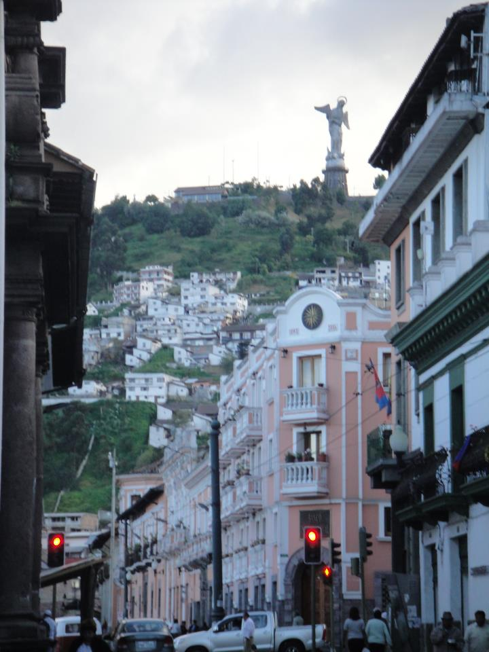 Old City (Quito)
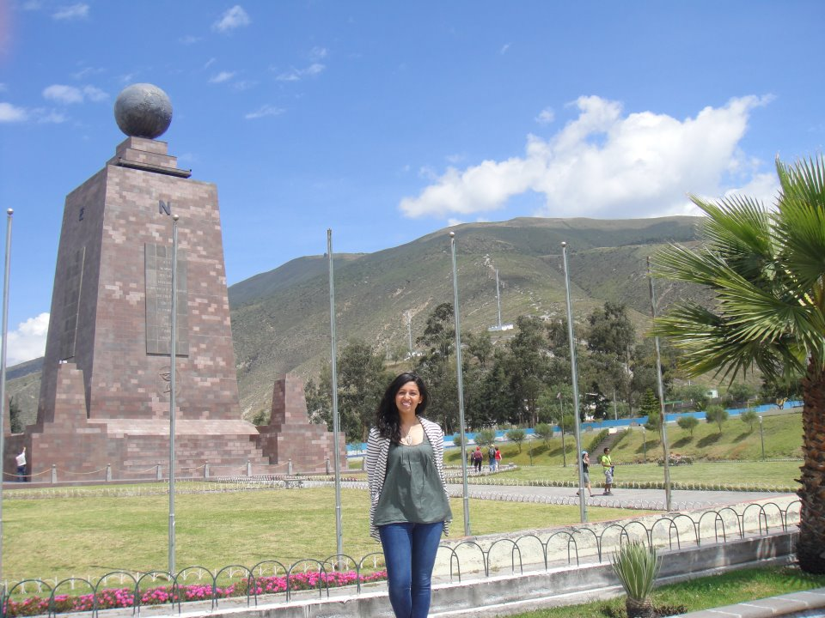Mitad del Mundo

