International Healthcare Volunteers – Ghana, 2011

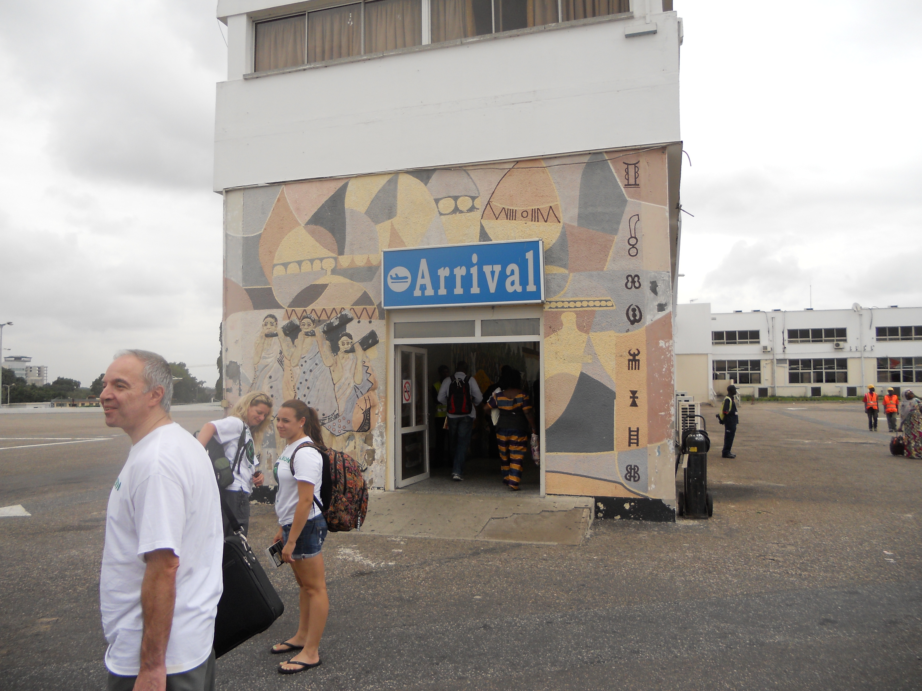The whole group for IHCV’s medical mission 2011 flew into Accra, Ghana. From there, we split up to head off to four different sites. My team consisted of a general surgeon, a general surgery resident, a gynecologic oncologist, an OB-Gyn, an internal medicine resident, a nurse anesthetist, an OR nurse, myself (a fourth year medical student), and a few junior volunteers. We took a short flight to Kumasi, the second largest city in Ghana, where we would spend the next week and a half at KNUST, or “Tech,” a university hospital. From our first morning arriving at the hospital, the OR team was ready for us. They already had three patients lined up and ready for general surgery that day – two hernia repairs and a thyroidectomy. The surgical team jumped right in despite our lack of supplies arriving from the States.

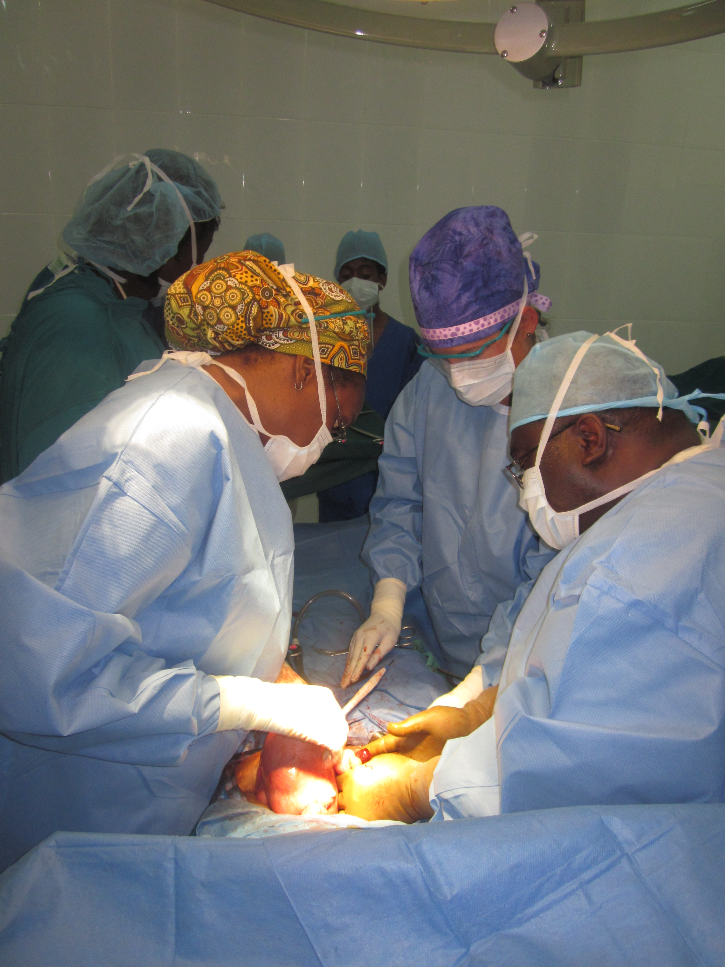Over the next week and a half, our team completed thirty-three surgeries, both general and gynecological. The general surgeries included more hernia repairs and thyroidectomies, as well as lipectomies, a keloidectomy, and an unprecedented laparoscopic cholycystectomy. The OR was packed as our general surgery team walked the Kumasi physicians and staff through laparoscopic surgery. Gyn surgery completed a myomectomy, a few hysterectomies, a tubal ligation, and a diagnostic laparoscopy for infertility workup. Our medicine resident spent most of her time in clinic seeing patients for more general concerns, mostly malaria, gastroenteritis, hypertension, and diabetes. With medicine, gyn, and surgical clinics combined, our team saw over 150 patients during our time in Kumasi.
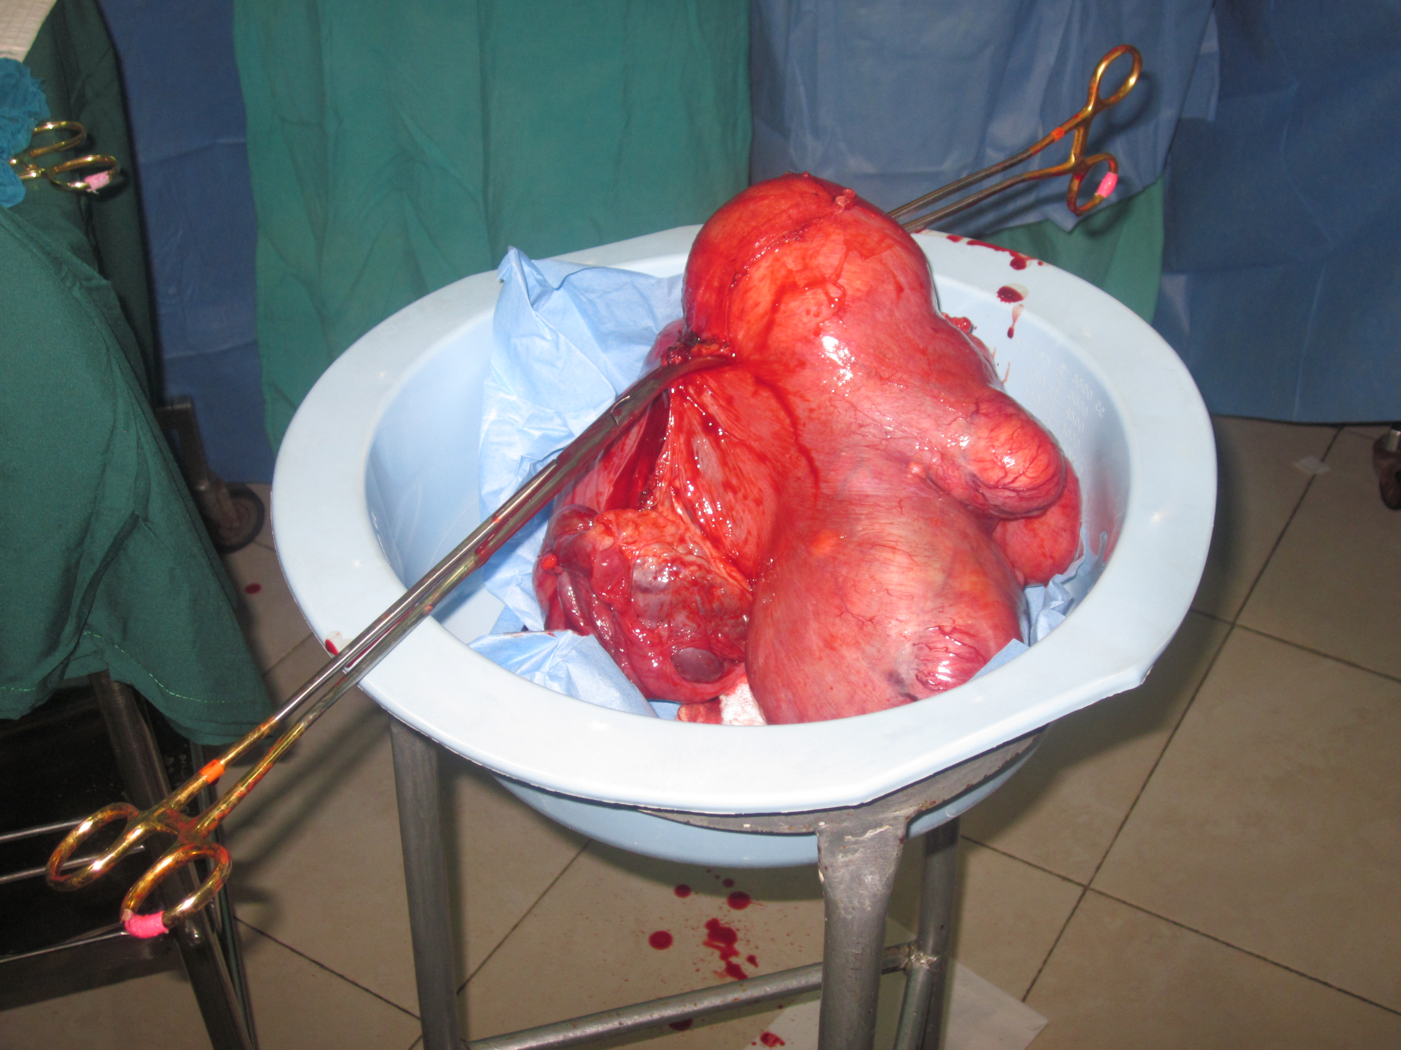

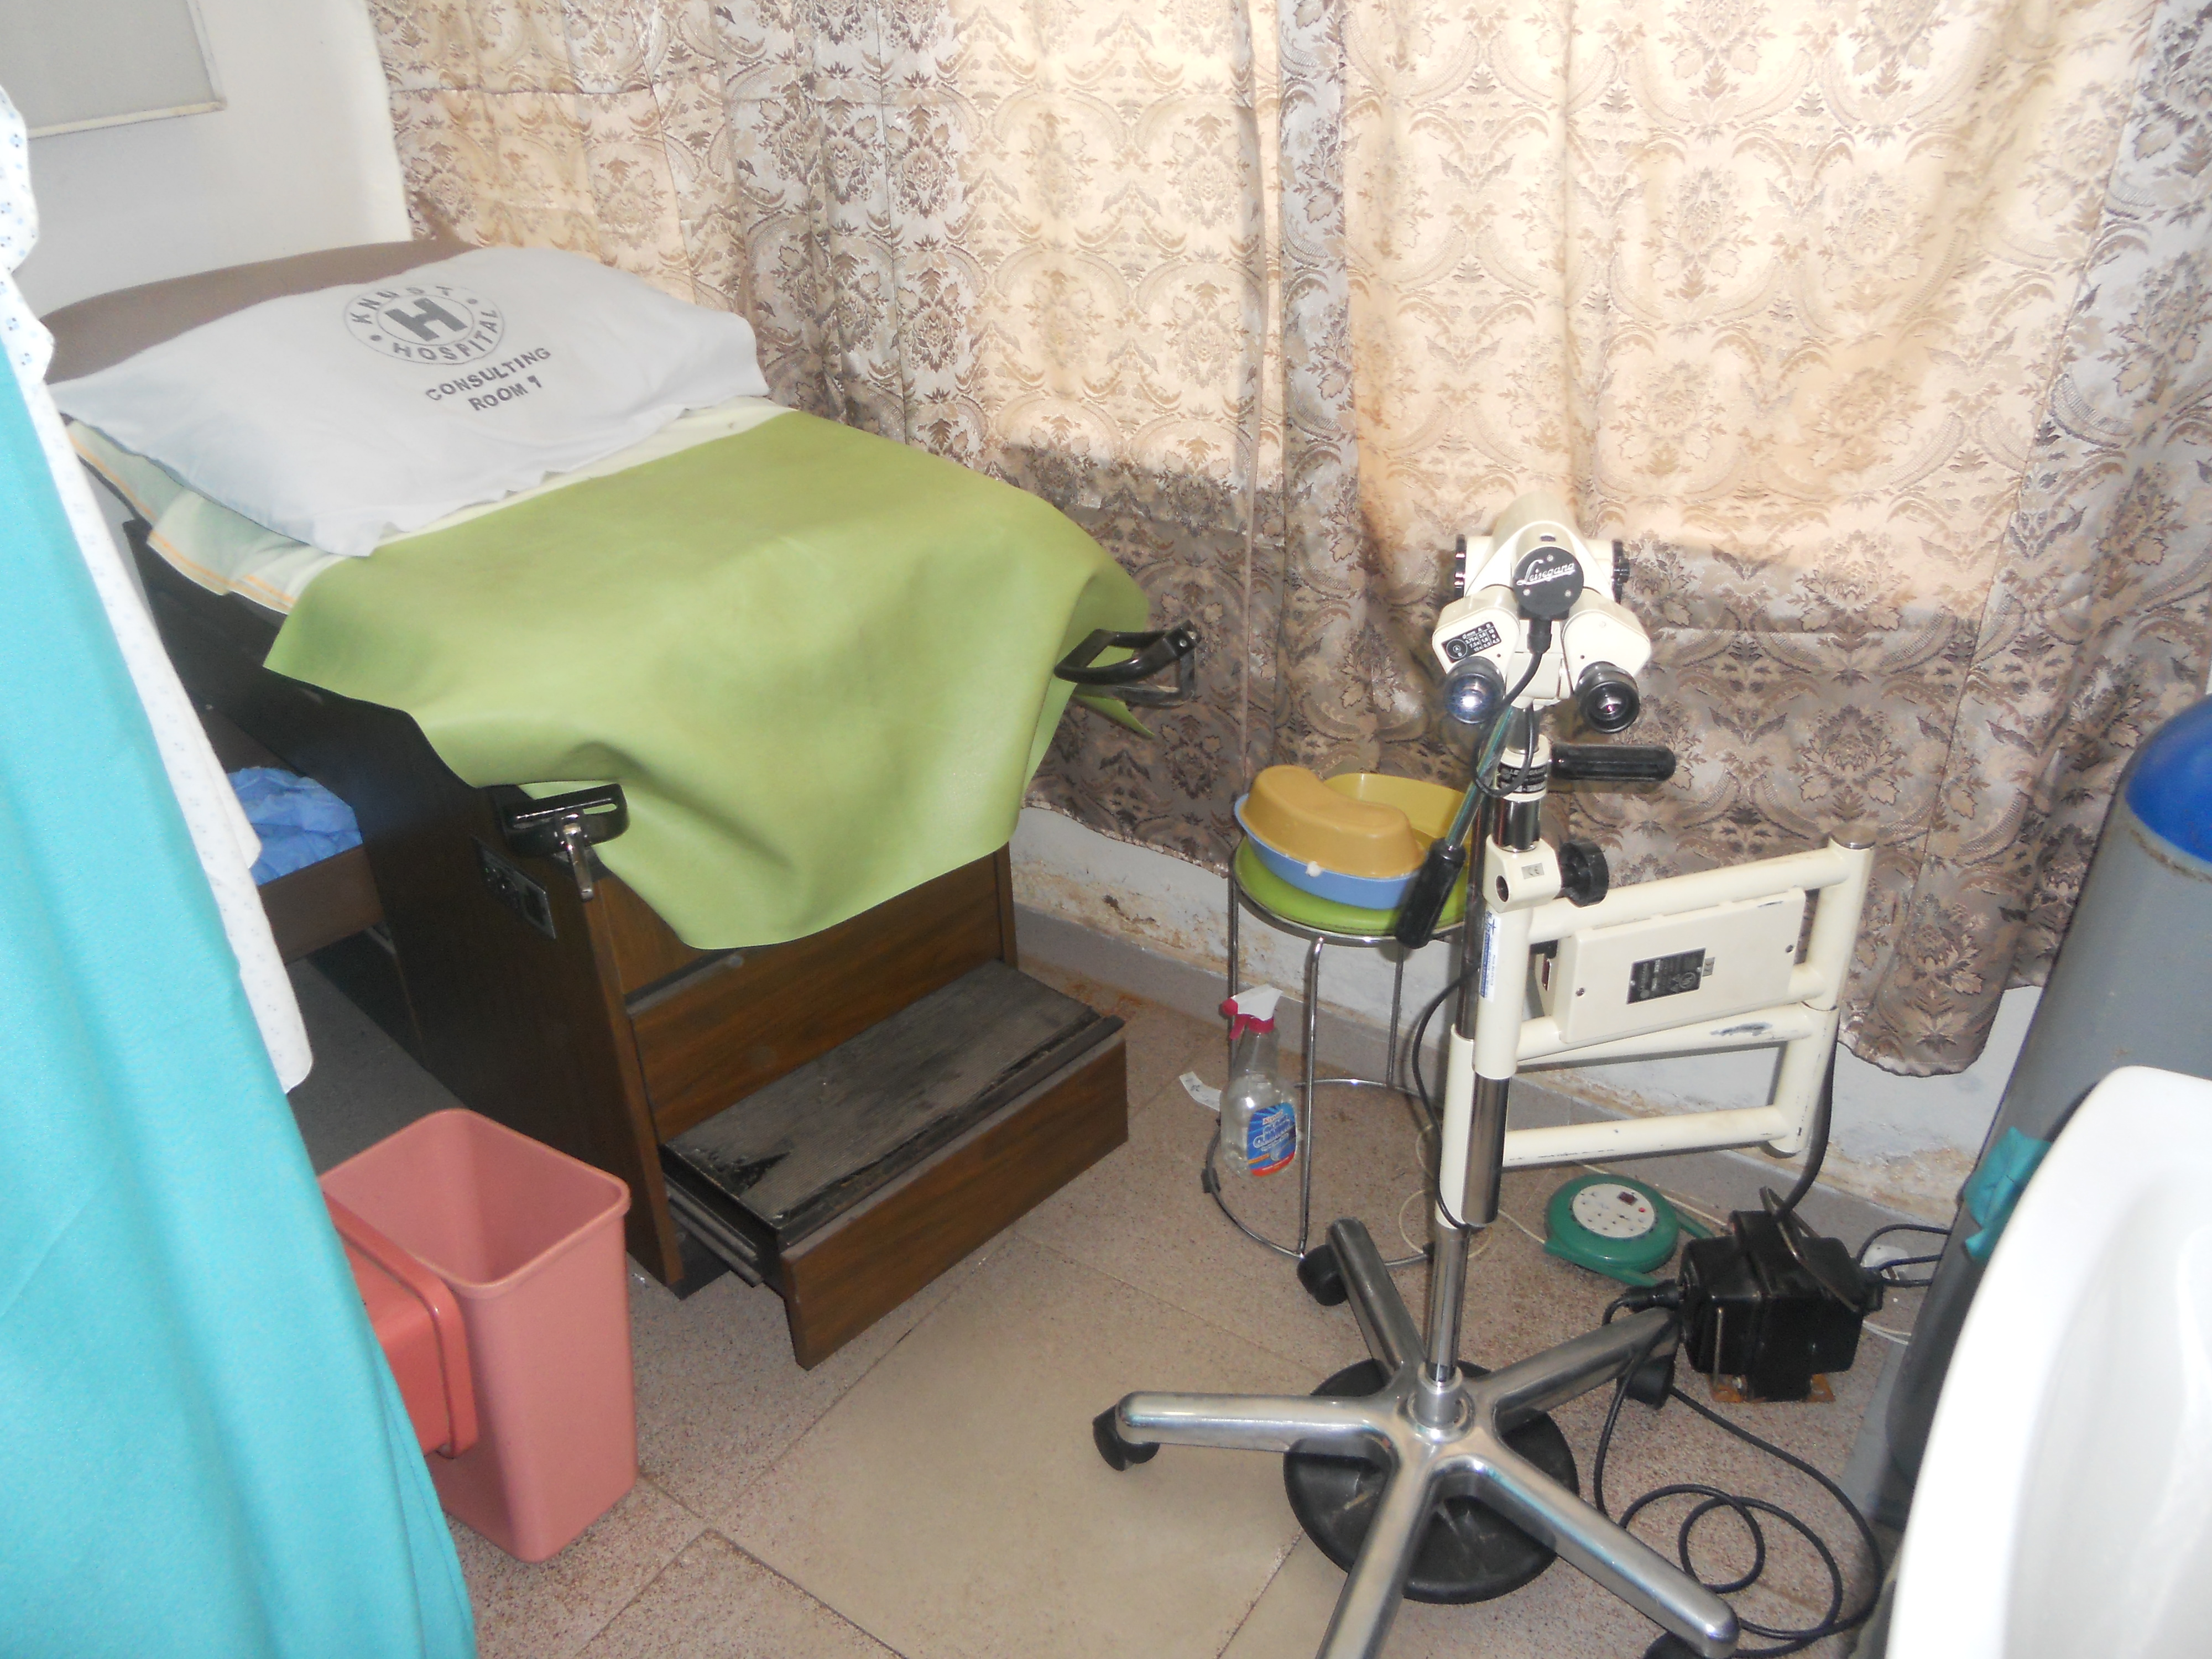Our group also continued efforts that had been made on past trips to promote cervical cancer screening. Cervical cancer is an preventable disease with screening, such as pap smears in the US. In Ghana, women die from cervical cancer due to lack of screening. This trip, IHCV brought a refurbished colposcopy machine, which we donated to KNUST hospital. We also trained one of their OB-Gyns, a resident, and a nurse midwife in visual inspection with acetic acid and colposcopy with biopsies. Our hope is that they will continue screening with their new training and equipment. Future work for next year includes training in LEEP for removal of CIN.

We still had time to explore the city. One exciting trip was to the market – Kumasi boasts the largest outdoor market in West Africa. We were thankful to our guides from the hospital for not letting us get lost in the endless rows of merchants. We also visited the historic Cape Coast Castle and Kakum Nature Reserve.
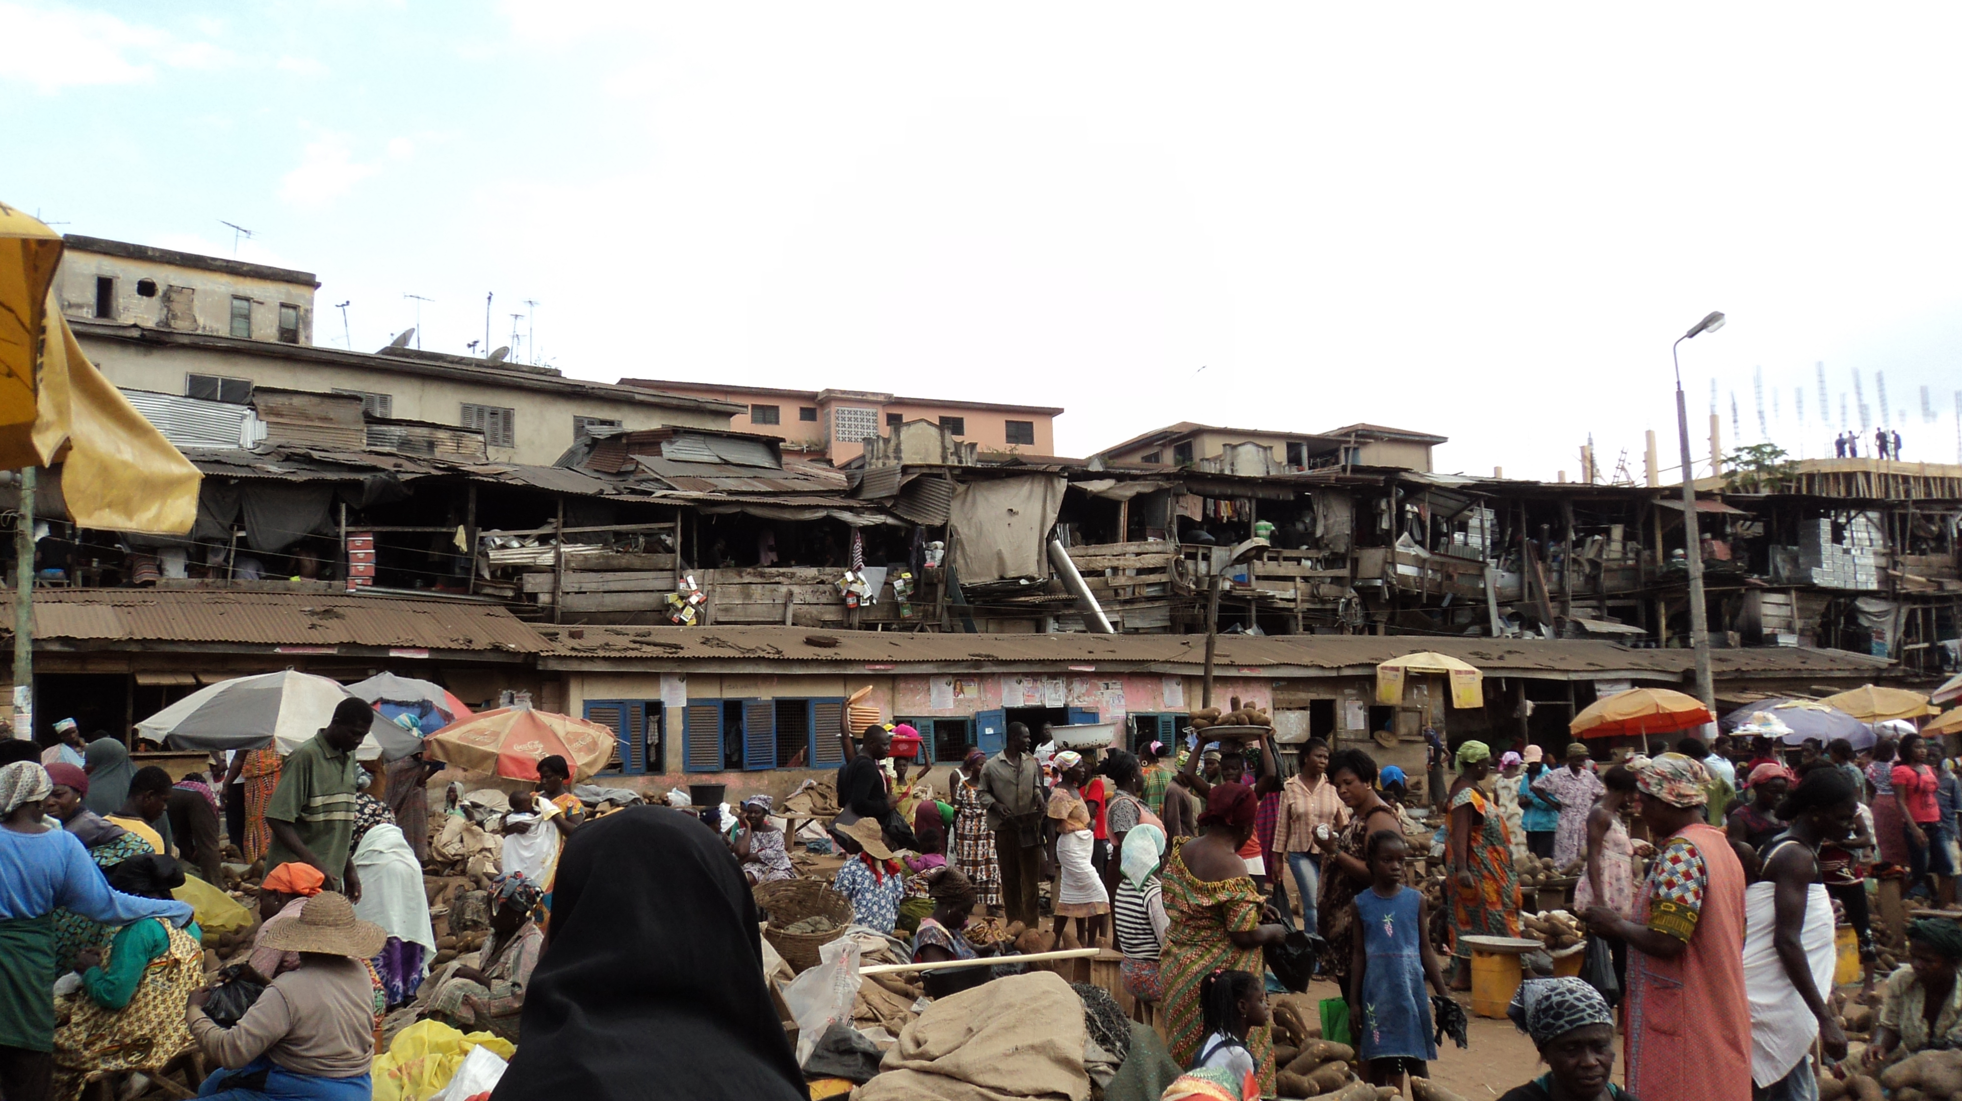

All of the groups met back up in Accra at the end of the second week. We had a lot to share about our varied experiences across Ghana. We enjoyed two days of relaxation by the pool and shopping at the cultural center before it was time to head back to the US.

Jennifer Weidner, MS4
Robert Wood Johnson Medical School - Camden

